Community participation in health service system.
Dr.Md.Emdadul Haque
In July 1985 I joined in chowgacha UHC as a medical officer. But there was no health complex, rather a chowgacha union rural dispensary (RD).That was the UHC. We, 7/8 doctors were posted at a time. But there was no sitting place .Because there was no place for more tables, so we sit 2 or more persons in a table. I seat in table with another person. There was a provision of taking money from patients. We denied it and the system was abolished within a few days. The drug supply was very limited. Dr.Saiful, (now he is the renaound cardiac surgeon of Washington DC)first donated the anti- helmenthic drug to the patient volentarily.

There was no in-door in the hospital.Chowgacha Officers club was functioning actively. The teachers of local college were the members of that club. We performed many good works with the help of officers club, Anirban club (student club).With the help of B.N.S.B. Khulna, an eye camp was organized by these organizations. It was a very successful camp, where local UP chairman, rich people & general community was engaged .The students of that club were very honest. This success was a bright example of community participation in my life. This system ran for a long 15 years. In 1986, an indoor of 6 beds started in chowgacha after shifting the UHC in a nearly public library. The honest enviornment made by Dr.Humayon UH & FPO and his colleague Dr. Saiful, Dr Sazed, Dr.Nikunja, Dr.Emdad (Now the principal of MATS Faridpur), Dr.Nasir, Dr.Tapon and other doctors & stuffs of the UHC. It was an honest factory. Any doctor & stuff came to this hospital maintained this honesty. One day, a patient of retained placenta came to the hospital but we the doctors failed to save her life. It was our failure which depressed me and later on I took training on obstetrics and saved many mothers.

I was posted in Lohagora UHC, Norail as a MO-MCH in 1988 and worked there upto 1995. I got post graduate degree on public health on maternity & child health (DMCH-FP) from NIPSOM under Dhaka University in 1991. I passed 7th BCS in 1985. I completed my foundation training from BPATC, SAVAR. During my training a acquired the knowledge about development economics specially indicators of development like PQLI, HDI. From MIPSOM I acquired the knowledge about basic health indicators, health problems in Bangladesh, community involvement and participation. I completed six months “Thana Gynae Specialist” training from SSMC & Mitford Hospital, Dhaka in 1994.

During my working place at Lohaghara UHC, Narail from 1988 to 1995. I made a good relation with local administration and officers through officers’ club. We involved in social work like eye camp, blood donor group organization, community involvement in data collection, community involvement in diarrheal disease treatment. The policy was low cost, effective and based on morality. With the help of UNO, Upazila Education officer. We collected data of SSC pass and same level and above level educated person of Lohagora with the help primary school teacher from each unit of compolsary primary education. We found that there are nearly 11007 SSC passed and above level person in Lohagora in 1993. Among them 76 MBBS and above level doctors, 68 grduated Engenier, 760 master degree holder, 2528 degree pass, 18 agriculture graduate and 13 PHD holder. If these developed human resources of the locality participate in the development of their community the area will develop automatically. We also collected data of literacy rate, birth rate, death rate, population growth rate, IMR, MMR sanitary latrine use rate throughout the upazilla of Lohagora with the help of high school teacher dividing the whole upazilla into 35 parts. Every unit was declared as a high school area and each of them was guided by a graduate high school teacher. Every headmaster and teachers must know the literacy rate of the individual village, so that they can analise the progress of literacy rate easily in every year and take local plan how to take action to increase the literacy rate to 100%. It was done with the help of local administration and involvement of the officers and college teachers of Lohagora. We organized two meeting among the high officials and influential persons of Lohaghara Upazila working in Dhaka city for the development of Lohaghara in Bangladesh Agriculture Research Council (BARC), Farmgate. With the help of local administration & local elite, we organized & mobilized the community for development and arrange a reunion of important personals like high officials, political leaders, teachers & important elites. Nearly two thousands and five hundred of such type to personals were present in the meeting and drew a plan of development described as “Lohaghara Declaration 1995’’. It was done with the help of a 15 members leaso committee headed by renound gynecologist professor Dr. Mokhlasur Rahman. He was the son of that upazila and UNO was the chief coordinator. It was an important of social mobilization.

During my service as MO (MCH FP) under DG FP (1986 to 1995) I observed MCH service is neglected in upazilla level of Bangladesh which is under FP directorate.

I returned back to health department in 1995 & posted as MO in Chowgacha Upazilla Health Complex and tried to development of MCH service system by health department under DGHS in upazila level. By local initiative we opened a ANC corner for pregnant mother, under-5 corner for under-5 children, basic EOC service, health education, development of MIS (Collection of birth and death record throughout the upazilla effectively with the help of family planning officer and UNO & done a base line survey and make an annual report in 1997) & implement all the component of primary health care in upazilla level by buildup a good team in 1996 at Chowgacha UHC. The officers club of Chowgacha declared that they will implement three component- one safe motherhood program, corruption free public examination and make a officers club scholarship fund for the meritorious students of class four and class seven. The teachers of two local colleges also were the member of the officers’ club. So the members of the officers’ club acts as an intellectuals group of Chowgacha upazilla. We planned a vision by the year 2010 for maternal service like 2020 vision of Malaysia in 1997.

In 1997 JICA helped Chowgacha Upaziila in front line MCH program and we took a plan a vision by the year 2010 about the health service system especially maternal and child health in every year we assess the progress of development. Our high officials always gives the reference of ICDDRB data. But the government have no upazilla level data which was very distressful for us. We collected quality data and every makes an annual report. The chronological progress of Chowgacha UHC.

To reduce Maternal and Child Mortality and Mobility and to ensure the quality services to the mother and child, UHFPO opened 4 special activities headed by medical officers in Feb. 1996. And from January 1997 to 2000 JICA helped us by Frontline MCH Program to implement the program by giving technical and logistic supports.
<4 Special activities>
- ANC-Corner – leaded by female Medical Officer for pregnant mother for effective ANC services who receive TT immunization in the Health Complex
- Basic EOC service by a Gyne & Obs. trained MO
- Under 5 corner for under 5 children for their nutritional assessment and treatment by RMO.
- Monthly birth and death record by specially developed format by health assistant throughout the Upazilla to asses the progress of maternal and child health status by health indicators supervised by UH&FPO.

In 16th December, 1996 blood grouping activities was started due to solve the need of blood in emergency. A local union chairman played an important role by purchasing blood grouping reagent and blood bag. We prepared a blood donor list.

A Sub-district level Women-Friendly Hospital with a Vision.
- Maximum utilization of Govt. resources with honesty and sincerity
- Integrated approach of Administration, Community Leaders & Health Management
- Providing Effective and prompt services through improved management system
- Show respect to the patients

The outdoor patient of the hospital is divided into four division male, female, under five and EOC. So, for every section a medical officer was responsible. Later on we opened ORT corner, EPI and breast feeding corner. Progressive increasing the number of mothers and babies are attending in the hospital and a EOC building was established. By reproductive health department of DGHS. Due to lack of two sweepers and one nurse we couldn’t function the EOC building in 2003. We tried in different way to solve the problem but failed. Then we followed the policies of local initiatives to arrange human resource on local industrialist supported a cleaner, we also participated to follow the idea “You divide your income into 10 parts, 9 parts use for your family and one part for your relatives and social work”. When In 2004 Chowgacha UHC was awarded for its best performance. One of the local indrustrialist donated a mobile phone in emergency in 2004 which was very helpful for communication. In 2007 when DSF program started, the community support system increased progressively. In 2011, mobilized 46 additional workers from community (26 volunteer, 12 cleaners and others 8) to fulfill the demand of the hospital.

- From Dec. 1999 Reproductive Health Department of DGHS and UNICEF gave logistic supports and human resources development (like medical officer trained in anesthesia).
- Form November 2000 started Comprehensive EOC program
- In 2004, 2005, 2006, 2007, 2008, 2009, 2010, 2011, 2012, 2013 the UHC was awarded by the Bangladesh Government and UNICEF
- From August 2006 Safe Blood Transfusion unit established with the aid of UNICEF.
- From April 2007 Demand Side Financing (DSF) program started.
- Women friendly Hospital declared in 2008.
- Hospital is declared as model health complex on 20 June 2008 and upgraded to 50 bedded hospital by Secretary of Ministry of Health & family welfare.
- Chowgacha health complex Model is replicable through out the country. Declared by Dr. Margaret Chan, D.G. WHO on 8th March 2010.

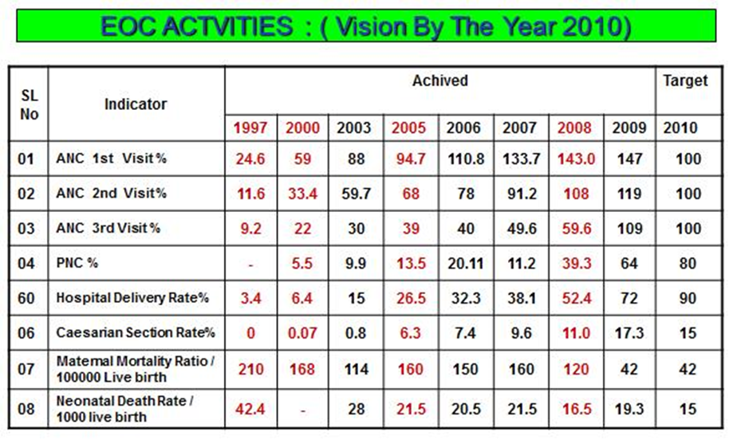

I joined at Monirampur UHC Jessore in September 2007. Within seven month we reform the health complex and implemented nearly all the component of “Chowgacha Health Complex Model” and organized the UHC as comprehensive EOC centre. Latter on the UHC was awarded for best performance in 2011 EOC activities as non EOC center in Khulna division.

I again returned back to Chowgacha UHC in March 2008 & working there as Junior consultant (Gynae & Obst). Hospital delivery rate of Chowgacha upzilla 72% in December 2009 & the upzailla already been achieved health related MDG in 2009. He took the initiative how community help the UHC by manpower support and nearly 44 manpower is support by the community the health complex In 2011the hospital delivery rate in chowgacha was 98.4% (in Chowgacha Upazilla total yearly delivery was 4500 but in hospital delivery was 4413 in 2011).

In May, 2012 I was posted as senior consultant (Gynae & Obst) in Jhenaidah Sadar Hospital and working for devolve the service system of the sadar hospital by the hospital authority and community support system.

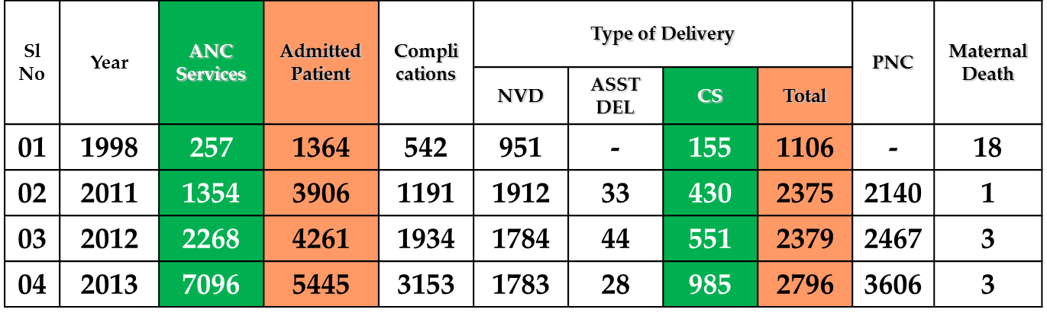
Nearly 18 people lives In Jhenaidah district & 37 thousand mothers delivered their baby per year & hospital delivery rate is 32%. Jhenaidah Sadar Hospital is the main health institution of the district. It is a 100 bedded hospital but running with 50 bedded manpower since 1994.
EOC Service 1998 to 2013
Sadar Hospital, Jhenaidah
The 5’S KAIZEN-TQM program started in this hospital in March 2011 with the support of BPATC Savar. BPATC Savar involved for technical assistance. but there was practically small change up to May 2012. In May 2012 the hospital authority desired to reform the hospital service system and taken the local initiatives and follow the 5’S Kaizen – TQM philosophy with the aid of community support system. The assistance of PATC Savar was completed in December 2013. A significant change occurred in the hospital management development system. In February 2014 SMPP (Save Motherhood Promotion Project) JAICA included Jhenaidah Sadar Hospital in their program to further improvement of the hospital by 5’S KAIZEN-TQM policy. From April 2014, Health Improvement Committee headed by local MP takes initiative to improve the hospital. Now the environment has been changed and increased the performance.
How we overcome the challenges: Step by Step
- Situation analysis and prepare a baseline survey report in June 2012 and compared the progress with the baseline report of 1998.
- Problem identification by the service provider (list of problames mensioned below)
- Basic activities.
- Govt. resources
- Scope
- Motivation of doctors, nurses and staff.
3Community motivation and social mobilization.
- Local administration DC ADC
- District health improvement committee which is headed by local MP.
- Local Govt. Mayor, district chairmen.
- Reporters and media personalities.
- Social workers, Human Rights Organizations, few NGO, teachers, industrialists, TIB & religious leaders.
- Reform of EOC program and community involvement in the hospital by follow the KAIZEN rule.
- Improved cleanliness and beautification of the outer environment.
- Involvement of Mayor. Ensure security of the campus and regular removal of hospital wastes, cleanliness of the drainage system.
- Removal of all posters.
- Make a boundary wall.
- Starting for the beautification of the campus by jhowgach collected from Jhekorgacha,Jessore.
- Celebrate A Big Cleaning Day in 17th March, the birthday of the father of the nation.
- Improved MIS and Display system.
- Improved supervisory authority.
- District health development authority.
- Ensure monthly meeting.
- Formation of QIT and WIT team.
- Idea sharing with Satkhira District Hospital visit.
- Coordination with officials of MOH&FW, DGHS, BPATC Savar, Divisional Health Office, ICDDRB and JICA.
- Achievements:
- Active community participation.
- High performance of EOC program.
- Improved cleanliness and beautification.
- Ensursure security.
- Improved revenue income.
- Achieve overall community satisfaction.
KAIZEN works summary
Before Kaizen Situation |  | After Kaizen Situation
1. Inadequate Documentation and Reporting System.  2. Inadequate EOC Services.  3. Inadequate Overall Cleanliness.  4. Less Community Participation and No initiative of Local Resource Mobilization for Hospital Improvements (No post of ayah, ward boy, guard, gardener, trolley man and electrician, cleaner is only 7).  5. Less coordination with local administration and community leaders.  6. Limited human resources especially cleaner, guard, gardener, ayah, ward boy, trolley man and electrician.  7. Demoralized environment, maximum 4th class employees were involved in corruption.  8. Insequred hospital for the staff and hospital as a whole.  9. Weak management system.  10. Beautification of the hospital was neglected. |  | 1. Improved Documentation and Reporting System  2. Improved EOC Services  3. Improved Overall Cleanliness  4. Significant Community Participation and Effective Local Resources Mobilization for Hospital Improvements (Arrange 57 manpower ayah, ward boy, guard, gardener, trolley man and electrician, cleaner).  5. Strong coordination with local administration and community leaders.  6. 57 man power supported by the community.  7. Developed moralized environment .Revenue income is increased.  8. Security is insured by the involvement of local MP, Mayor, DC and SP.  9. Improve management system.  10.Over all beautification of the hospital improved .

The performance of the hospital is given below:
Table - 1
Sl No | Year | Emergency&outdoor Patients | indoor Service | Bed occupancy rate
01 | 1998 | 81795 | 12973 | 126%
02 | 2011 | 170854 | 22435 | 146%
03 | 2012 | 171070 | 22951 | 143%
04 | 2013 | 192791 | 24643 | 165%
05 | 2014 | 227868 | 27905 | 180%
06 | 2015 | 277301 | 29562 | 193%
07 | 2016 | 296235 | 32300 | 214%
08 | 2017 | 340932 | 35569 | 242%

Table-4
Operation Service 1998 to 2017
Sl. No. | Year | Major | Minor | Total
01 | 1998 | - | - | 1089
02 | 2011 | 780 | 4857 | 5629
03 | 2012 | 977 | 5433 | 6410
04 | 2013 | 1294 | 4923 | 6217
05 | 2014 | 1339 | 4512 | 5851
06 | 2015 | 1582 | 7004 | 8586
07 | 2016 | 1383 | 5348 | 6731
08 | 2017 | 1578 | 5899 | 7477

EOC service:
Nearly 4.5 thousand mothers admitted and 2.5 thousand mothers delivered their baby in the hospital every year but only five (5) EOC beds are allocated for them. Six govt. nurses and one govt. aya work in the ward. So five non govt. workers (Cleaner + Aya) work there in lieu of money earn from the patients. More than 40 mothers admitted every day but there is one wash room in the ward. There is one consultant (Obs. & Gynae) and one consultant (Anesthesiology), but no post of MO in both departments of the hospital.
Changes in the EOC program: • Improved health education and MIS system. • Organized effective ANC & PNC corner. • No. of EOC Bed increase to 21 with increased number of washroom. • Rearrangement of Labour room, pre-labour room, EOC-OT. • Twelve (12) manpowers (volunteer, guards, aya & cleaners) are supported by community donors. • Improved communication network. • Shoe-free environment with improved infection control system. • One medical officer is trained on anesthesia posted for 24 hours EOC service.

Achievement: In Jhenaidah Sadar Hospital, the highest number of NVD & total delivery is performed among all the govt. hospitals in Khulna division in 2017.
Table-2
EOC Service 2011 to 2017
Sl. No. | Year | ANC Service | Admitted Patient | Type of Delivery
 |  |  |  | NVD | CS | Total | PNC
01 | 2011 | 1354 | 3906 | 1912 | 430 | 2375 | 2140
02 | 2012 | 2268 | 4261 | 1828 | 551 | 2379 | 2467
03 | 2013 | 7096 | 5445 | 1811 | 985 | 2796 | 3606
04 | 2014 | 10811 | 6095 | 1945 | 941 | 2886 | 3729
05 | 2015 | 13251 | 6558 | 1944 | 1090 | 3034 | 3771
06 | 2016 | 13397 | 6487 | 1920 | 1016 | 2936 | 3600
07 | 2017 | 15360 | 6568 | 1854 | 1143 | 2997 | 3973
Table-3
Comparative Data of EOC service of 3 best performing District Hospital of Khula Division in 2017
Sl. No. | Year | ANC Service | Type of Delivery
Sl. No. | Year | ANC Service | NVD | CS | Total
01 | 100 bed Jhenaidah Sadar Hospital | 15360 | 1854 | 1143 | 2997
02 | 250 Bed Hospital Jessore | 13152 | 1172 | 1778 | 2950
03 | Khulna Medical college Hospital | 7399 | 1448 | 1365 | 2524
Revenue Income: Revenue income is increasing. It is an indicator of improved financial management. The income at Jhenaidah is the highest among all the district of Khulna division. The income was 60,44,775 Tk. in 2015 which increased to 70,59,560 Tk. in 2017. Community Support System: The system was approved by district health improvement committee which is headed by local MP. The others members of the committee are DC, SP, Civil Surgeon, Mayor, and President Press club, President BMA etc.
- 57 manpowers (Cleaner 20, Aya & wardboy 23, Guard 6, Volunteer 5, Trolley man 3) get 2000 to 3000 Tk. per month per month. is supported by the community. Among them, 18 manpowers are supported by doctors.
- MP of Jhenaidah 2 donated 14 manpower supports with continuous monitoring system in the hospital.
- MP of Jhenaidah 1 donated furniture for the hospital with a cost of nearly 1 lac taka.
- Mayor of Jhenaidah Paurasava plays a major role in cleanness of the outer environment of the Hospital and repaired the boundary wall and made 4 dustbins with a cost of nearly one lac taka, and support 3 man power
- Retired Joint secretary Mir Sahabuddin donated a generator for 24 hours OT service with a cost of nearly 33 thousands taka.
- Chairman of Zahedee foundation donates 10 manpower support and an intercom system with a cost of nearly two lac taka.
- Mr. Anisur Rahman (Khoka) (Previous chairman, Jhenaidah Paurasava) donates one man power support and also support for shoe free environment.
- UP Chairman, Harishonkorpur, Jhenaidah repairs 3 benches for seating of EOC outdoor patient.
- Some of the Pharmaceuticals help in forms and discharge certificate and seating arrangement.
Situation of the hospital in May 2012 -1
Situation of the hospital in May 2012 -2
- Unprotected Campus
a. Addicted person moved here and there at day and night.
b. Campus unclean goats and cows moved everywhere in day.
c. Front of the hospital was full of posters.
d. Broken cycle stand and there was a shade of polithin in front of the cycle stand.
e. Vesoz Garden was unclean and full of hospital waste.
- Emergency:
a. Full of broken lockers
b. Unhygienic
c. Used as a cycle store at night.
d. No boiling system. Infection control system was neglected.
e. Addicted person worked in emergency department.
f. No trolley man.
g. No slopping for trolley in front of the emergency department.
h. Privacy was neglected during stomach wash of the patient.
i. Corruption was not prevented.
3. Outdoor:
a. No patient separation. Male female and child treated in outdoor by every outdoor doctor.
b. No IMCI Corner. c. No FP Unit.
4. Blood Bank:
a. No worker for 24 Hours blood bank support.
5. Indoor:
a. Unwanted items within the ward. Like broken patient bed.
b. Unhygienic environment.
c. Patient in paying cabin and paying ward without govt. charge.
d. No table and chair in paying cabin.
e. Non Govt. worker would take charge from the patient and some of the govt. workers also involved in corruption.
6. Dead body room:
a. Unclean.
b. Unused large telephone box for 10 years.
c. Workers would take heavy charge from the relatives of the dead person.

- EOC ward:
a. Only 4 govt. bed and 4 extra. Total 8 beds.
b. The ward was unhygienic and foul smelling.
c. Privacy was neglected.
d. ANC Corner system ineffective.
e. One washroom with broken door.
f. No rexin sheet and unclean mattress of the beds.
g. Mal use of oxytocic drug.
h. Weak infection control system.
i. Consultant reside outside the campus.
j. No health education system.
k. No pre labour room.
l. No night round of the consultant.
- OT:
a. Some of the none govt. workers would take charge from the patient.
- No round of superintendent of the hospital even one in a month.
- No RMO, in charge RMO worked for six years.
- Information display system was neglected.
- One super were charged by local MP and one super fled away.
- Frequently, Hospital stuffs faced physical and mental torture.

